Scrum Meeting #1

# Ashton Ford

*Acting scrum master and note taker*

Photo of repository, February 25, 2019.

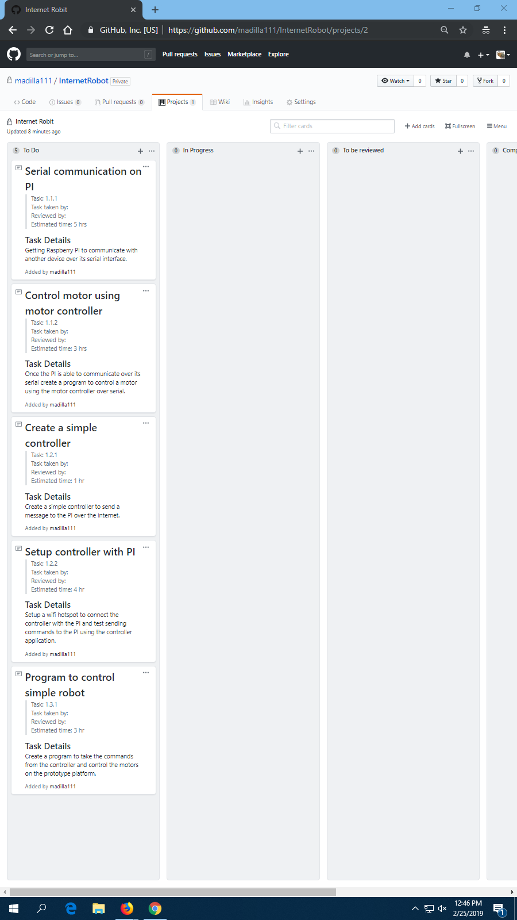

**New tasks:**

Creating a simple controller – Ashton Ford

Setup controller with PI – Ashton Ford

Serial Communication on PI – Bailey CW

Program to control simple robot – Nick Kaiser

**What was accomplished since last meeting?**

This is the beginning of the project, so nothing has been accomplished. We have created a repository and assigned starting tasks to create a mini project and have it ready for a presentation by Thursday, February 28th, 2019.

**Impediments & Resolutions**

None